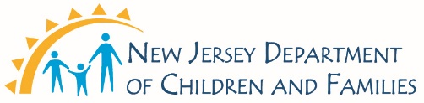

CHANGE OF STAFF FORM
Adding/Deleting Staff to/from current New Jersey Medicaid Identification Number

Please check one :
- Add Staff
- Delete Staff

1. Provider/Agency Name: ___________________________________ 2. Existing Medicaid #: _____________________

3. Staff Name: _____________________________________________ 4. Requested Effective Date: ________________

5. Staff Members Email: _________________________________ 6.DOB: ______________ 7.SS#: ______________________

8. If Bilingual, specify the Language(s) ___________________________________________________________________

9. Service Type: IIC _____ BA _____ IIH Clinical/Therapeutic ______ IIH Behavioral ______
ISS(Tech 1)_____ (Tech 2)_____ (Tech 3)______

10. NJ Clinical License #: _______________________________________________________________________________

11. License/Certification Type: ________________ 12.Certificate # ______________________________________

_______________________________ _________________________________ ____________________
Print Name of New Staff Signature of New Staff Date

If Adding Staff:
ATTACH COPY OF CURRENT LICENSE(S) AND BOARD CERTIFICATION(S) IF APPLICABLE
ATTACH COPY OF CURRENT RESUMES FOR ALL STAFF BEING ADDED

PROVIDER AGREES: To comply with all program participation requirements as agreed in accordance with your original Provider Agreement with the New Jersey Division of Medical Assistance and Health Services (DMAHS) (reference FD-62). To comply with the Children’s System of Care (CSOC) policies, procedures, and regulations.

THE CHILDREN’S SYSTEM OF CARE, PROVIDER/AGENCY OR DMAHS MAY, ON 60 DAYS WRITTEN NOTICE TO THE OTHER PARTY, TERMINATE THIS AGREEMENT.

Provider Agency Representative Information:

_________________________ _________________________________ ________________________ _______
Name of Provider Agency Signature of Provider Representative Email/Phone Date

Department of Children and Families
Division of Children’s System of Care
PO Box 717
Trenton, NJ 08625

